Name: IBRAHIM ALSHAYEA, ID: 202176470, Date: 3/23/24

Task1:
In Exercise 1, I implemented a BinaryHeap class, completing core heap operations such as percolateUp(), percolateDown(), buildHeapBottomUp(), and buildHeapTopDown(). These methods ensure correct heap structure maintenance during insertion, deletion, and heap construction. The implemented methods were then utilized to construct a heap from a given array of integers and to produce the expected sorted array output.

Task 1 Code:
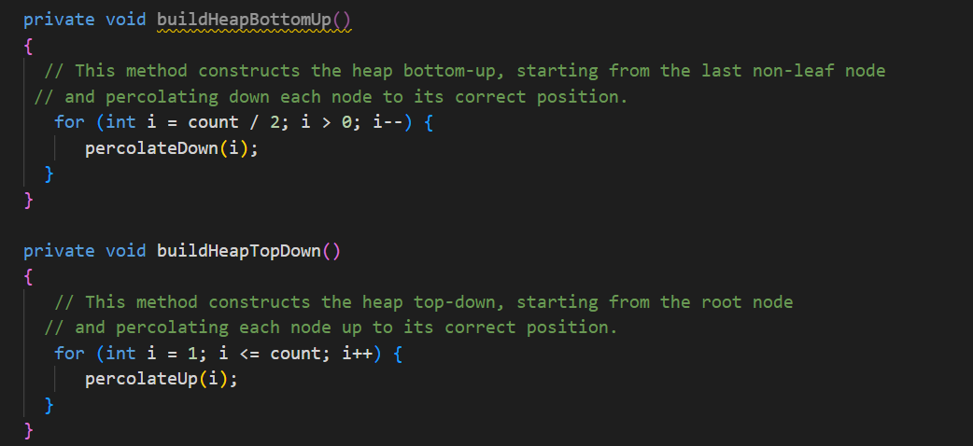
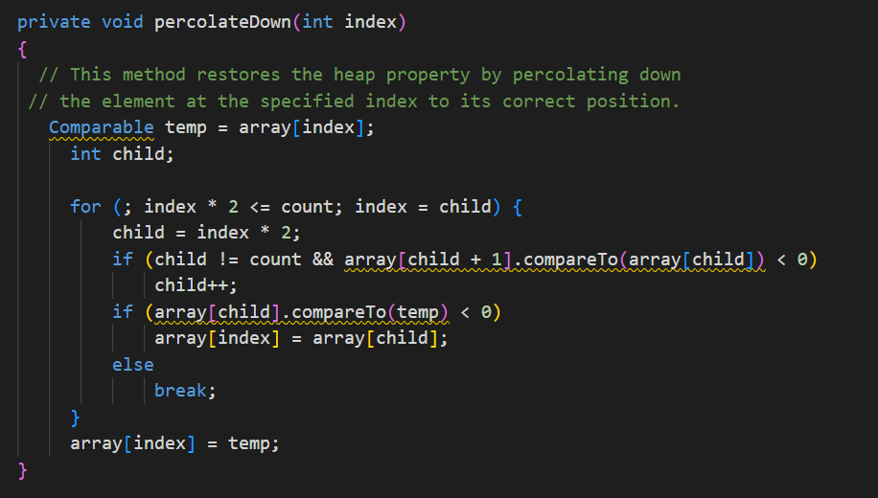
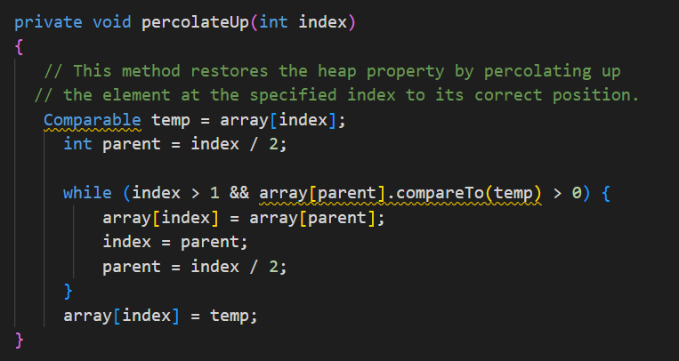
TASK1 Outputs:
Output for bottom-up heap construction:
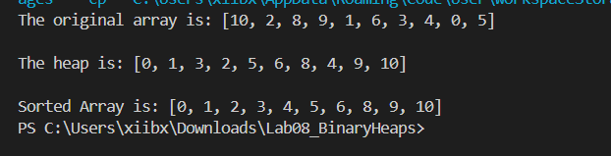

Output for top-down heap construction:
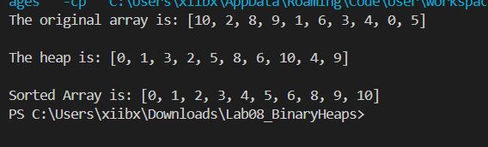

Task2:
The code consists of two classes: Hospital and Patient. The Patient class holds patient information like name and urgency level, implementing Comparable for sorting. In the Hospital class's main method, it generates 10 patients with random attributes and displays their original arrival order. Using this array, a binary heap is created to prioritize patients based on urgency. Then, the heap is sorted to determine the treatment order, showcasing the binary heap's role in managing patient treatment prioritization effectively.

Task2 sample output:
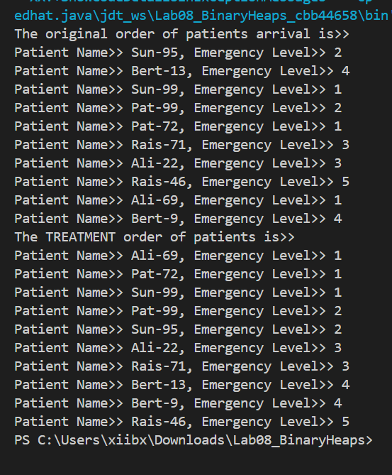

Task2 code:
